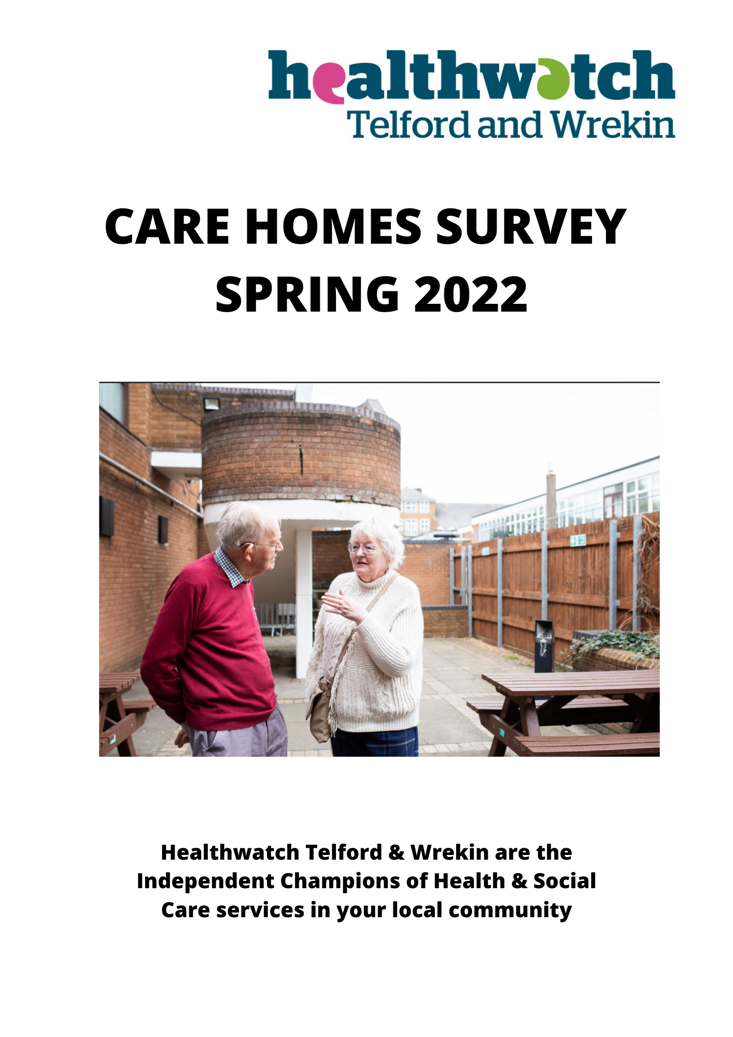

Report on Care Homes Survey responses, 22 July 2022

Background
This survey took place from March 2022, at the tail-end of most Covid-19 restrictions on Care Homes. The aim was to get an overview of what happened in Care Homes as a result of Covid-19, with regard to visiting opportunities, activities and extra care for residents. The survey was sent to the Managers of all Care Homes within Telford and Wrekin, with a request to distribute it to residents, staff and residents’ families and friends.
We would like to thank all the Care Home Managers who distributed the Survey on our behalf.

Findings from Residents
Thirty-Three Residents completed the survey
- Roughly half of the residents who responded reported that the Care Home’s policies and restrictions on visitors have had an impact on their ability to see visitors.
Residents’ quotes
“I haven’t seen any difference I get all my support from staff”
“Yes, it has impacted my ability to see my family in person, but I have spoke to them on the phone”
“Yes, most definitely. but only to give extra protection to patients during Covid”

- Responses showed that there was a low level of awareness of the Essential Care Giver Scheme among residents and less than half of residents expressed an interest in the scheme.

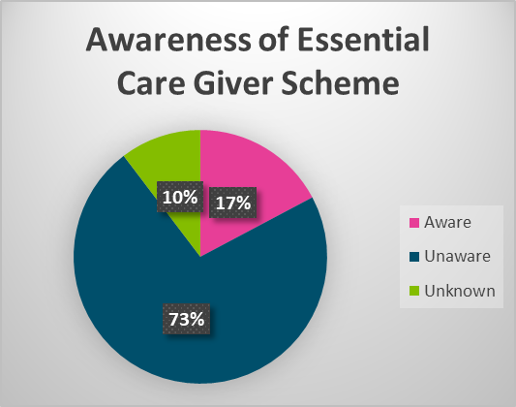

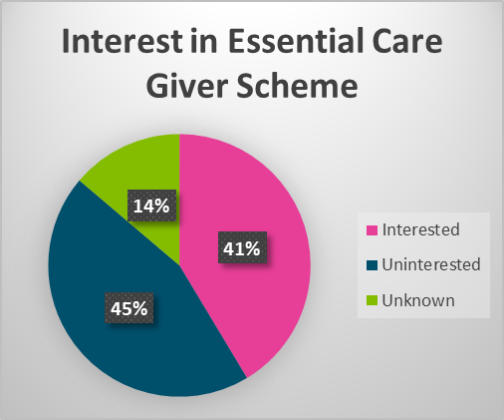

- Around two thirds of residents felt that there was ample provision and support for them to keep in touch with their friends and relatives via methods that were not face-to-face: this mainly consisted of phone calls but also in a few cases video calls.

Residents’ quotes
“Yes, ample with facilities on all floors”
“I have been given a phone which in pay for”
“Haven’t got any family so it doesn’t matter”
“Yes, this home gives me enough opportunities as I like to speak to them on the phone”

- With regard to opportunities provided to meet residents’ mental, physical and emotional needs, there was a mixed picture. Some reported that a range of activities were offered by the Care Home, others reported a lack of organised activities. Other residents said they organised their own hobbies and activities (e.g., reading, drawing, walking) and further responses indicated that some residents were not capable of taking part in activities.

Residents’ quotes

“There is no Activity worker at the moment “
“I personally like drawing and I get help printing”
“Chatting doing jobs housework”
“I watch TV and
“Didn’t know there was any “do my games and puzzles”

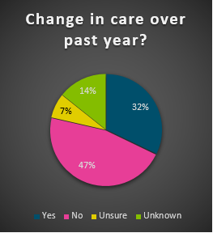

- In response to a question about the provision of opportunities for extra care, aside from the usual day-to-day activities, just over half of residents reported positive experiences, but there were also some comments about lack of staff to provide extra care. Around half of residents felt that there had been a change in the level of extra care provided over the past 12 months, with a few responses suggesting a reduction in the level of extra care and activities.

Residents’ quotes
“Not enough staff”
“Yes, I am looked after very well”
“The care is excellent that’s my reason for coming into the home”
“Initially yes but now is always on my own except for mealtimes”

Any other comments

“Care and feeding very good”
“Not really I am leaving soon”
“More contact with family”
“I am more than satisfied with present conditions. Look
forward to outside movement”
“If I want anything I can ask for it”
“I am very happy”

Conclusions
In general, a mixed picture was presented, with roughly half of residents appearing to be satisfied with the arrangements for visiting, extra care and activities, but some residents indicating that these could be improved to give them a better experience. There was only limited awareness of Essential Care Giver status.

Findings from Family and Friends
Eight Family and Friends completed the survey
- In response to the question “Do you feel you can see your relative/friend in the home as much as you’d like”, more than three quarters of Family and Friends respondents said “Yes”.

- Friends and relatives mostly felt that restrictions on visiting were justified and proportionate to keep residents safe, even though it was a difficult and frustrating situation. However, one respondent expressed concern that restrictions were still in place at the time of their response to the survey, a situation which seemed to them excessive and counterproductive.

Relative/Friends quotes
“From June 21 to Nov policy on visiting was acceptable and sensible. Since end of Nov21 I have not been able to see my Father other than by exception through a screen. This restriction imposed by Public Health England seems excessive and counterproductive”
“Frustrated at times but appreciate that priority to residents’ wellbeing and safety is taken into account”
“Ok during lockdown it was hard not being able to visit more important to keep residents safe”
“They seem reasonable given the very strange conditions over the last two years”

- Just under half of Friends and Family respondents said that they had been aware of the Essential Care Giver status, with one respondent saying that they were aware of the scheme “but not sure what it meant”.

- A slight majority of Friends and Family respondents replied that they would like to be given, or would like a close contact to be given, Essential Care Giver status, but not all respondents were in favour of the scheme.

- There were mixed responses from Friends and Family respondents regarding the availability and effectiveness of non-face-to-face methods of communication. Phone calls, video links and letters were all valued. Some respondents pointed out the practical difficulties faced by residents who were offered video calls e.g., poor eyesight, also variable signal for phone calls. It was pointed out by one respondent that the residents’ access to Skype calls now appears to have ended. The extra workload on staff helping residents to communicate was also recognised.

Relatives/friends quotes
“Having you own phone helps, although the signal isn’t the best with poor eyesight and arthritic hands answering calls can be difficult. Staff are very busy and not always able to assist. Weekends can be frustrating as the phones are not always answered “
“Yes, phone and zoom calls. Not sure what else could be done”
“My brother is unable to communicate verbally but knows it is me on the phone”
“Mum has a phone in her room and skype calls can be booked”

- There were also mixed responses regarding how well Family and Friends have been kept updated by Care Home staff on their loved ones' wellbeing while they were unable to visit. Just under half the respondents to this question reported a lack of communication, or miscommunication by the Care Home.

Relatives/friends quotes
“Yes, when I requested info about care”
“There has been times when communication has been lacking. We have arrived for a planned visit to be told the home was in lockdown due to Covid cases, and we couldn’t see dad. He was negative! if we had known earlier, we could have arranged alternatives.”
“Yes, we are in regular contact with the home”
“Not always”
“Yes, a couple of times nursing staff have called us”

- When asked for additional comments, responses from Friends and Family included concerns about Care Home staff shortages and difficulties getting to see the Care Home Manager, although there were also positive comments about how well staff have coped with the challenges of looking after people during Covid-19. There was a suggestion that Care Homes /Social Workers could provide information on staff roles and arrangements in the Care Home - in booklet form - for a new resident and their family.

Relative/Friends quotes
“The home seems to struggle with rotation of staff (though this may be because of Covid or pay levels
“Cannot think of anything except when is open visiting, likely to be resumed, but this is unknown in the current climate”

Conclusions
Overall, the survey responses showed that Friends and Family were generally satisfied with visiting restrictions during the pandemic, although they sometimes found the situation frustrating. There were some concerns around communications, these were in regards to contacting their loved ones and receiving updates from Care Home staff. A minority of Family and Friends had been aware of Essential Care Giver status.

Findings from Staff
Fourteen staff completed the survey
- More than three quarters of Care Home staff respondents reported that they had received support from their Management Team relating to their own mental, physical and social wellbeing needs, including adjustments being made to protect staff if pregnant or with health issues, including stress. Several staff members reported management giving them the opportunity to talk through issues, and the point was made that good management of the home and good staffing levels were of benefit to both residents and staff. Around one fifth of staff, however, reported that their own wellbeing needs were not being met by management.

Staff quotes
“Currently pregnant, Risk assessments in place and time of allowed for any pregnancy related appointments.
“We are getting good mental support from the management; I am happy about that. If you well organise annual leave, we would be more happy and healthy. Because it’s the time to visit our family and friends.”

“It has been a stressful Home with Covid, and Management have been really good and fair with Me, If I need to vent the Management have been supportive. Particularly my deputy Manager. I am clinically vulnerable so it has been difficult in work with Covid, but my DM has always made sure that I'm safe.”

- Most Care Home staff who responded to the survey stated that a wide range of events and activities such as music, crafts, dance and exercises had been put in place in their Care Homes to support residents’ physical and mental health and wellbeing. However, there were a few Care Homes where there appeared to be little or nothing in the way of activities for residents, with one home currently not offering anything but trying to recruit an Activities Co-ordinator. Some staff members commented that more activities could usefully be introduced. Several staff counted a resident’s contact with other people via video calls or window visits as part of the range of activities. Responses to the question on activities also included details of activities such as parties and events including friends and family, which could not have taken place during the periods of severest restrictions.

Staff quotes
“There is a daily events/activities programme daily. All residents are encouraged to take part.”
“Encouragement with facetime and phone calls with family due to being in lockdown in Covid.”
“Not that I know of.”
“We have a range of activities in scheme, Music, Arts and Crafts, Puzzles and even some customers enjoy dancing. We as staff have ensured that their needs have been met dancing. Customers have also managed to have a weekend holiday by the sea.”

- When Care Home staff were asked: “Do you think residents have enough opportunities to see their family or friends in the capacity as Essential Care Givers? How do you feel about the Essential Care Giver Status?”, there was a mixture of responses. Around half of staff felt that Essential Care Givers had played an important role, others felt that residents had enough opportunities to see family and friends anyway.

- When asked for other comments, staff responded that the Care Home sector had been under a great deal of pressure. Care Home workers had pulled together and worked really hard to look after their residents at a time when those residents could not see their friends and families. There was awareness of the need to address staff shortages, for the benefit of both residents and the workforce.
Staff quotes
“Yes, one of our customers has regular contact with her father weekly.”
“Customers are able to access WhatsApp on the tablet, so they can see and speak to their family.”
“Encouragement with facetime and phone calls with family due to being in lockdown in Covid.”
“Kitchen staff have worked together with Office and Care Staff to ensure pleasurable Theme based buffets where residents and their families all interact with each other during a social event.”

Any other comments
“I think that we all do a really great job here, the care sector is under so much pressure at the moment. Hopefully this will improve in the future.”
“Please provide more staff, for effective and quality care, as a result, both can be healthy and happy.”

Conclusions
Care Home staff report that they have been working very hard to support their residents at a time of unprecedented challenge. Staff and residents have, in general, been given good support at this difficult time, but there are gaps in that support and more needs to be done to address this situation, not least addressing the staff shortages in the Care Home sector.

